Report

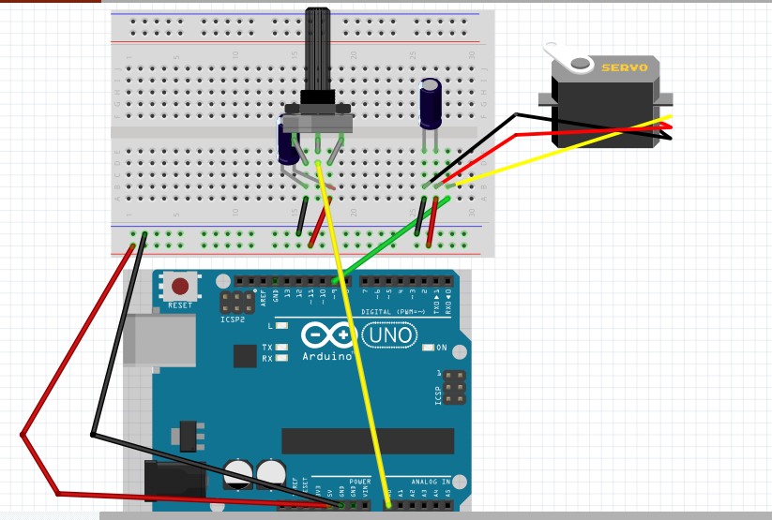

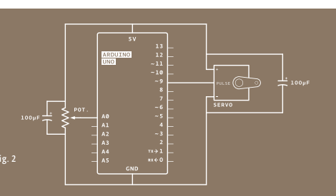

This lab allowed to through rotate potentiometer to control servo motor rotation.

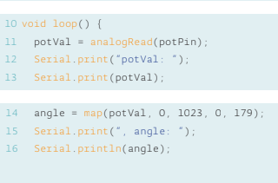

use a function called map() to change the scale of the values coming from the potentiometer. And output angle.